**CF PROJECT**

**DOCUMENTATION**

**Abstract:**

This report contains the information about the website of an hospital . This website is made by using HTML ,CSS , and bootstrap. The website contains four pages one is about **home,** second is **about us** , third is about **doctors** and the last is about **contact us.** In creating this website we use sublime text 3 and MS Access to hold the records and history of patients and doctors by creating the databases in which you can insert, add or delete the data. By using html tags, jumbotron ,bootstrap external and internal links we created this website. Further information about the website is discussed below.

TABLE OF CONTENTS:-

* Introduction to website
* Content About pages
* Responsive Website
* Specialist Doctors List
* Record Management System
* Access to the website

Introduction to website:-

We have designed a website of hospital system which is named as RAHAT MEDICAL HOSPITAL by using different tags of HTML ,CSS and BOOTSTRAP. Some of the cards which are used in this website are directly copied by bootstrap website. And design or layout of the website is created by using HTML and internal CSS to make it better and easy to understand. We also use external CSS in this website and also linked this website to other applications.

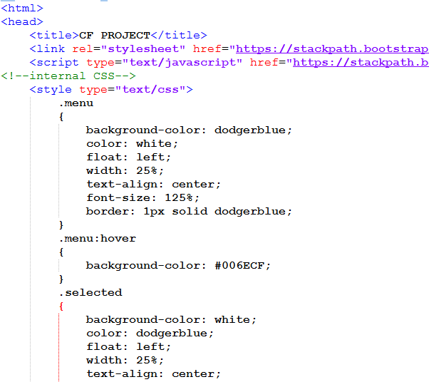

CONTENT ABOUT PAGES:-

As it is already mention in the above page that this website is divided into four pages. There are some short description about those pages.

Home:-

In this page we have mentioned the departments of RAHAT MEDICAL HOSPITAL so that people can easily got an idea that what kind of facilities and departments are there. We used different images in this page to design this website in a better way.

ABOUT US:-

This page contain detail information about the website. In this page we have provided some reason to prefer this site and hospital over other hospitals. Content contain the facilities such as operation theatre, ICU ,Emergency wards ,specialist clinics , professional doctors and advance technical tools and machineries to facilitate the patient in a better way.

Doctors:-

In this page we have mentioned the detail information about the doctors, their education and qualification. There are some doctors name and their specialities. List of the doctors available in RAHAT MEDICAL HOSPITAL is mention in this page.

CONTACT US:-

This page contain the information about the website and email of the hospital and phone numbers of the hospital management staff so that users can easily contact to the hospital and management system to related issue. We have mention all the resources in this page to contact with hospital system.

RECORD MANAGEMENT SYSTEM:-

To creating this website we also used MS ACCESS to hold the records of the hospital .We have created two databases one is for patient’s record and their history and the second one is for the doctors ‘s record such as their qualification, timing , appointments ,fees and contact number etc.

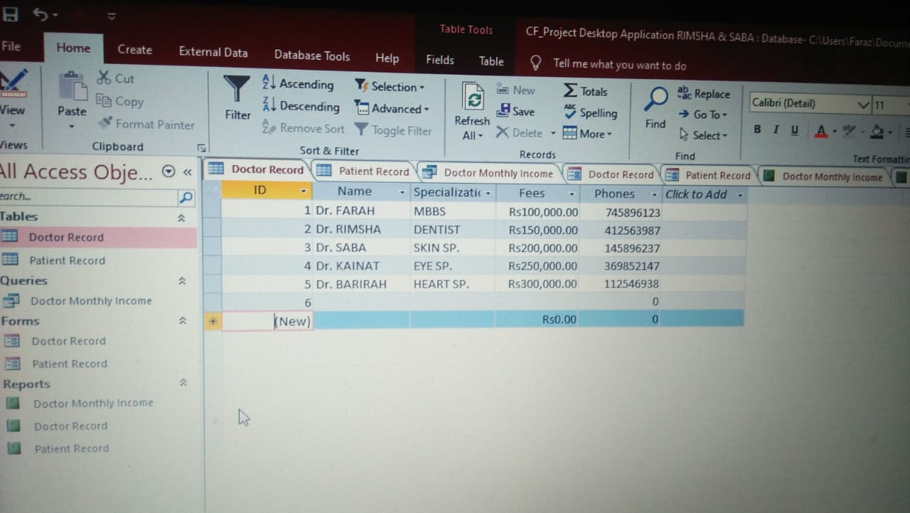 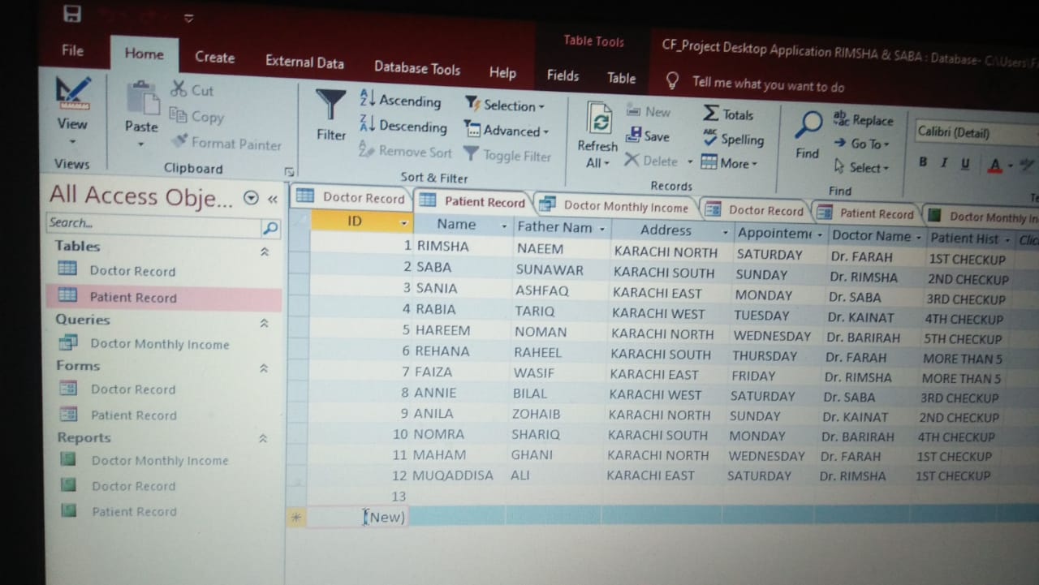

***Doctors Record patients Record***

***Responsive Website:-***

This website is user friendlyand a responsive website**.** It can set its layoutaccording to the desire of the user**. Responsive** design is an approach to **web page** creation that makes use of flexible layouts, flexible images and cascading style sheet media queries. The goal of **responsive** design is to build **web** pages that detect the visitor's screen size and orientation and change the **layout** accordingly. This website is user friendly

***CONCLUSION:-***

In this report we have mention all the features ,the tools and technologies which are used in making this website such as html ,CSS, Bootstrap, MS Access are the tools and technologies. Instead of these we use some special cards which are directly copied by bootstrap website. This website is user friendlyand a responsive website**.**